How to load old Assistant versions

Introduction

This document describes how to force VEConfigure to not use the latest version of an Assistant, but an earlier one. A procedure that is useful sometimes for testing & diagnosing.

Note that we not at all recommend or expect installers and distributors to go through such procedure by themselves. This is only to be done at specific request and instruction of Victron Energy, to be able to pin point a specific issue in a specific situation, for example when the problem has proven to be hard to reproduce in Victron R&D.

Procedure

An up to date installation of VEConfig includes all officially released versions of all assistants.
(The reason for this is that the newest VEConfig should be able to read all installations. Also installations build with older assistant versions.)

While creating a new Multi installation, VEConfig will display only last version for each assistant.
In some cases however (i.e. for testing purposes) it can be advantageous to use a previous version of an assistant.

This can be realized by disabling the newer versions of an assistant.
When the VEConfig program starts, it scans through all the available assistant files and builds the list with the latest version of each assistant.
So the trick is to hide all later versions of that assistant from VEConfig.

This can simply be done by changing the extension of the assistant filename or by moving the file to another directory. It will then not be recognized anymore.
(Of course one can also delete these files but then it becomes more difficult to restore the system.)

The assistant files can normally be found in the “C:\ProgramData\VE Configure tools\Assistants” directory.
(Note that the ProgramData is a hidden directory.)

Below is a screenshot of the ESS assistants in that directory:

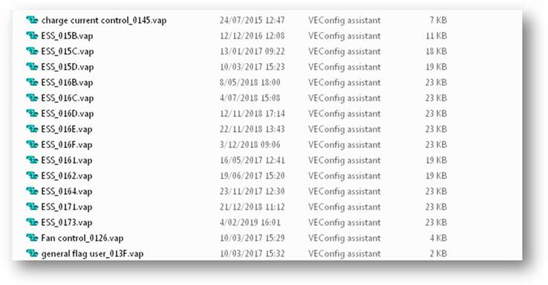

Each filename ends with _xxxx. This xxxx is a hexadecimal unique number. It can be regarded as the assistant version number.

Now if you want to configure a system with for instance the ESS_0164 you should do the following:
- Close VEConfig
- Change the extension of all ESS assistant files with a higher hexadecimal number to for instance “vapx” as shown below.
(You can also choose to move these files to a temporary directory.)
- Restart VEConfig

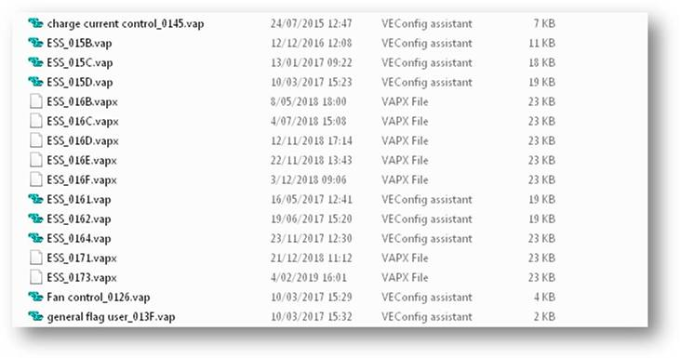

WARNING: This directory contains also some ‘system’ assistants (names start with ‘asf’) making these ones invisible can have unexpected/unwanted results.

