Changelog VEConfigure 3 (9004xxx)

V9004247– Released 16-4-2025
- Using the ESS or PVInverter assistant in a demo device (Port selection -> fake target with full options) an error could be raised, depending on the selected settings. This is solved.
(nb This error did not occur on real devices, only on demo devices.)

V9004246– Released 16-4-2025
- Extra features added which can be used by assistants.
(These new functions are used by the “Microgrid operation switcher” assistant.)

V9004244– Released 24-3-2025
- The Microgrid active warning could still appear briefly directly after connecting to a device.
This is solved.

V9004243– Released 24-3-2025
- Removed bug: The Microgrid active warning could appear erroneously, depending on exact configuration.

V9004242– Released 24-3-2025
- Added microgrid support

V9004241– Released 8-9-2025
- Added option for AS/NZS4777 appendix M to enable Feed-In.
(Requires also a firmware update!)
- Added settings for (future) firmwares which support Microgrid.

V9004240– Released 3-3-2025
- Added support for the German §14a EnWG handling.

V9004239– Released 22-10-2024
- Compatbile with Venus OS V3.50
- Corrected Cos Phi defaults for Czech gridcode.
- Under the hood changes for the upcoming microgrid option.

V9004238– Released 24-06-2024
- Added support for “External transfer switch” firmwares.
(see firmware changelog for xxxx552-s99)

V9004237– Released 27-02-2024
- Added support for gridcodes Czech, Poland, G98 and G99.
- Improved the “Export settings” option. (Strange errors in the lay-out could occur).
- A lot of “under the hood” improvements

V9004236– Released 01-08-2023
- Made suitable for other AC voltages than 230V and 120V.
- Added option “limit internal charger to prioritize other energy sources”
- Fixed erroneous indication “2x120V” on some Multi models.
- Some additions in preparation of a new controller to be used in future.
- Some “under the hood” improvements

V9004235– Released 15-05-2023
- Added support for Quattro-II 2x120V models

V9004234– Released 17-01-2023
- Added support for the “Generator” option for Quattro’s which provides a way to disable the gridcode on AC Input 1. This option is introduced in firmware versions 26xx501.
- Correctly displays “Quattro-II” when a Quattro-II is connected.
- ARM64 driver for the MK3 interface is included (menu Special -> USB Drivers)
- Improved Monitor display. (In some cases there was not enough space reseved for displaying AC currents >=100A (i.e. US models..))
- Updated MK2/3 driver and included new MK3 firmware.
- Several minor under the hood changes.

V9004233– Released 17-11-2022
- Added support for the “Disable VSense” option introduced in Multi firmware xxyy500

V9004232– Released 26-08-2022
- Bug removed which could result in a runtime error.

V9004231– Released 25-08-2022
- Updated to support gridcodes G98/1 Amendment 6, G99/1 Amendment 8
- Some under the hood changes

V9004230– Released 31-01-2022
- Prepared for the new Australian grid code
- Improvements to prevent assistant setup to become corrupted.
- The setting for Repeated Absorption will not be disabled when using a VE.Bus BMS provided that the firmware in the Multi/Quattro is 26/27xx494 or later.

V9004229– Released 11-11-2021
- The 230Vac demo models support all gridcodes now
- Automatically repairs corrupted assistant setup due to which some systems reported “internal error occured” when configuring assistants.

V9004228– Released 29-10-2021
- Supports firmware 489 which includes VE.Bus BMS support.
- Assistants are included in the installation file.
- Several minor improvements.

V9004227– Released 02-07-2021
- Supports latest 485 firmware which enables Quattros and Multis to select certain gridcodes.
(external IP protection required)
- Displays L2 values for a 2x120 unit.

V9004226– Released 12-05-2021
- Supports latest 482 firmware which has an additional gridcode parameter.

V9004225– Released 01-04-2021
- Minor improvement for remote update process.
(Prevents some messages from appearing more than once during the process.)

V9004224– Released 09-03-2021
- Phoenix Inverter Compact: AES settings can be changed.
- Support added for MultiPlus-II 12/3000/120-50 2x120V
- Added support for remote update

V9004223– Released 23-09-2020
- Bug fix for remote files from VGR devices.

V9004222– Released 21-09-2020
- Added support for gridcode “Other: AC Neutral path externally joined (not compliant)”

V9004221– Released 14-08-2020
- Added support for gridcode “Northern Ireland: G99/NI April 2019”
- Improved Com port handling.

V9004220– Released 03-04-2020
- Prepared for Danmark gridcode
- Added “Max AC current” setting in VDE grid codes.

V9004219– Released 27-03-2020
- Added support for Austria grid code TOR-Erzeuger A V1.1:2019-12.

V9004218– Released 20-01-2020
- Added support for Belgian grid code ed 2.1 09-2019

V9004217– Released 04-12-2019
- Added support for European gridcode EN 50549-1: 2019

V9004216– Released 11-10-2019
- Added support for two new gridcodes for Australia and New Zealand.
These gridcodes are added in firmware 26xx466 and should be used in MultiPlus-II systems where the Neutral Input and Neutral Output are externally tied together.
- Added support for the new gridcode for France (VFR 2019) which is also introduced in 26xx466.
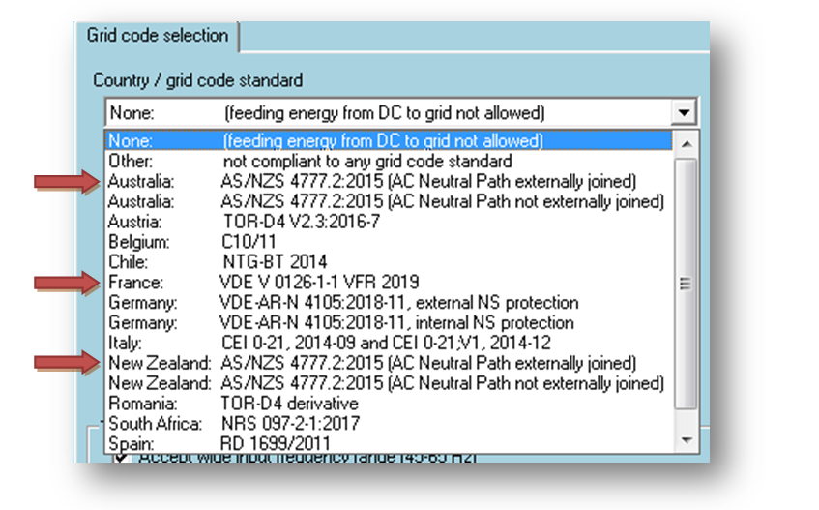

V9004215– Released 20-09-2019
- AS/NZS4777 now supports P(U) and Q(U) functions.
- Option ‘Use Aux1 (if available) as disable FeedIn signal’ now visible for VDE_Ziehl.
- Minimum Cosϕ for UK is ±0.8 now.

V9004214– Released 20-08-2019
- Changed some texts.
- Support for older (non-VE.Bus devices) was broken. This is fixed.

V9004213– Released 16-07-2019
- Bug fix: The defaults for the reactive power curve (this is a gridcode related setting) could under some circumstances be wrong.
(n.b. this bug only effected the defaults in VEConfig. The values could just be set correct and send to the device)
- Bug fix: The informational warnings ‘Changes require reset’ and ‘password required’ (see figure below) could become frozen when the gridcode was changed.
This had no real effect on the functionality but was inconvenient.
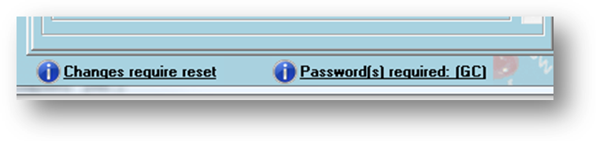

V9004212– Released 11-07-2019
- Bug fix: Remote VEConfigure was broken.

V9004211– Released 10-07-2019
- Included MK3 version 1170207.
- Added grid code support for:
  - VDE 2018:11
  - UK G98/1 March 2019, G99/1 May 2018
  - Chile
  - Romania (based on TOR-D4)
- Lifted the additional restriction on “DC input low restart” for 24 and 48 volt devices.
For these devices, the minimum voltage is now defined by the device firmware.
(For a standard 24V/48V Multi the minimum restart voltage will become 20.6V/41.2V)
- With Multi firmwares xxyy460 and up, VEConfig will now indicate why the grid is rejected and will also show an indication of the remaining waiting time.
(After the waiting time the unit will connect to grid provided that there is no assistant which prevents the unit from connecting to grid and that the required relay test is performed.)
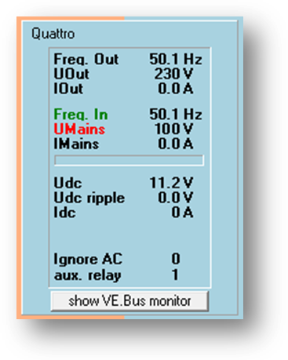 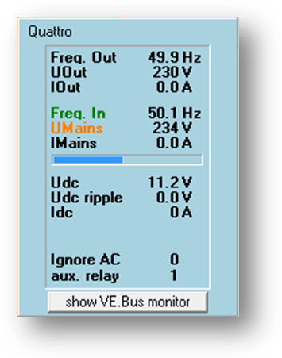 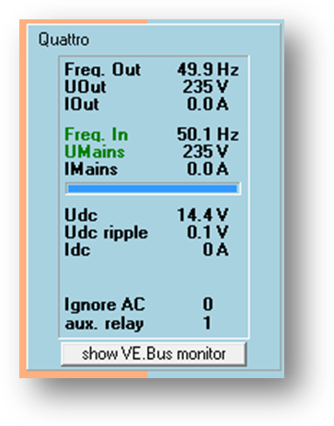
- In a “multi phase” systeem the VE.Bus monitor will now display per phase if the unit is in phase with the mains input. This way it becomes easy to detect a ‘swapped phase’ installation error.
- Removed the Rolls battery default.
- Added support for devices with adjustable “charge voltage temperature compensation “.

V9004210– Released 01-04-2019
- Includes latest MK3 version
- Supports new MultiPlus-II models
- The ‘Show NS protection log’ button was erroneously visible when the option was not supported by the connected device.

V9004209– Released 19-02-2019
- MultilPlus_II/MultiGrids (firmware revision >454) can be used in an extended VE.Bus system now. (When selected grid code is ‘none’). This VEConfigure takes care that the grid code is not accidently set in that case.
- NS protection log can be readout irrespective of the selected grid code.
- Low SOC shut-down is now enabled/disabled by a checkbox and not just by setting the value to zero.
- Some minor changes.

V9004208– Released 13-11-2018
- Repaired bug introduced in 207 which resulted in some assistants generating an error.

V9004207– Released 12-11-2018
- Added support for “SOC low shut-down” settings.
- several ‘under the hood’ improvements.

V9004206– Released 1-10-2018
- Bug removed: When selecting a language other than English the texts for some of the reactive power related settings became corrupted.

V9004205– Released 10-09-2018
- Added support for VDE reactive power settings
- Bug removed: When a grid code is selected the GND relay setting was accidently grayed out for all model types. Now it is only grayed out for the MultiPlus II / MultiGrid

V9004204– Released 04-06-2018
- Added support for external current sensor for MultiPlus-II.

V9004203– Released 26-05-2018
- GND relay functionality enabled for Multigrid/MultiPlus-II when selected grid code is ‘None’.
- Under the hood improvements.

V9004202– Released 13-04-2018
- Added TOR-D4 support

V9004201– Released 12-03-2018
- Under the hood update of communication modules.

V9004200– Released 14-02-2018
- Added French, Spanish and Belgium grid codes (UTE C15, RD1699, C10/11)
- Added support for new safety option ‘Do not restart after short circuit’
- Some minor improvements

V9004199– Released 28-11-2017
- Added South Africa grid code (NRS097)
- Added option to disable LOM
- Updated USB drivers

V9004198– Released 07-09-2017
- Bug removed: Weak LOM setting was invisible when opening a remote file
- Minor modification to help file.

V9004197– Released 01-09-2017
- Supports weak LOM setting.

V9004196– Released 19-07-2017
- New MK3 code included.

V9004195– Released 23-06-2017
- Bug removed which resulted in VEConfigure refusing to close when data was written to a remote setting file.

V9004194– Released 19-06-2017
- latest MK2/MK3 firmware included
- Supports new subversion mechanism
- Works ok again with Phoenix Charger
- Removed a bug which could result in errors during readback of a stored settings file.
- A lot of minor and ‘under the hood’ improvements

V9004193– Released 20-04-2017
- Removed ‘Watson’ password for enabling assistants.

V9004192– Released 10-04-2017
- added support for Quattro 48/15000

V9004191– Released 28-02-2017
- added support for AS/NZS4777 grid code

V9004190 – Released 24-10-2016
- Bug fix. (Could not send data to Multis with firmware revision 1xx or 2xx)

V9004189 – Released 21-10-2016
- Bug fix. (Issue with first time grid code selection.)

V9004188 – Released 12-10-2016
- Support MultiGrid Multis
- Added VDE internal NS protection option.
- MK3 supported
- Integration with VE.Bus System Configurator and VE.Bus Quick Configure tools:
Passwords are remembered during a complete session.

V9004187 – Released 11-03-2016
- Some textual changes only.

V9004186 – Released 09-03-2016
- Added VDE-AR-N 4105:2011-08 grid code setting for use i.c.w. with external interface protection relay.
- Bug removed which could occur when accessing a corrupted *.VAP file.
- Some ‘under the hood’ changes (uses new MK2 driver library).

V9004185 – Released 05-02-2016
- Solved an issue with the VGR.
(VGR’s could not read the new VSC file format introduced in 9004181.)
Now a special check is done whether the file is likely form a VGR. If so, a warning is issued (because the VGR does not necessarily support all settings available in the device) and when saving the settings, a file according to the old format will be generated.

V9004184 – Released 13-01-2016
- Solved the problem that when using firmware xxyy404 in combination with VEConfigure 3 (V9004183) all grid codes other than CEI refused to feedback energy.

V9004183 – Released 8-01-2016
- Improved CEI grid code support.

V9004182 – Released 7-01-2016
- Added support for CEI grid code.
- Handling for private assistants improved.
- Various other (minor) improvements.

V9004181 – Released 9-11-2015
- The ‘set to current value’ command from the assistant popup menu now sets the parameter to the correct value instead of to the default value.
- Reduced the nr of error boxes when starting VEConfigure on a VE.Bus system directly (so not starting it from within VE.Bus System Configurator or VE.Bus Quick Configure.)
- For xxyy403 and up: Removed the warning that a devices can only be used stand alone when a grid code is selected.
- Several under hood improvements.

V9004180 – Released 29-09-2015
- Bug removed which resulted in errors during configuration of assistants in case internet was not available.

V9004179 – Released 16-09-2015
- In ‘demo’ mode one can now play with the assistants without the need for a password.
- Some ‘under the hood’ changes to enhance capabilities of assistants.

V9004178 – Released 24-08-2015
- Bug removed: Regardless of the related settings, a corresponding battery default was never found.

V9004177 – Released 15-07-2015
- Changed assistant setup will now generate a ‘reset required’ notification.
- Bug removed which resulted in erroneous signaling/ not signaling the ‘reset required’.
- Dialog boxes (during close when a remote file is open) changed. The user will get warned whenever a reset is performed.
- Export form can be resized.

V9004176 – Released 01-07-2015
- Bug removed: Defining a new default battery did not work properly when the connected system was a 24/48 V system.
- User interface changed. This to lower the amount of popup boxes.
- Default colors back to ‘old’ style. (Can still be changed by the user)
- The ‘Allow enable feed in’ checkbox is hidden now. The value is automatically changed depending on the grid code selection.

V9004175 – Released 22-06-2015
- Bug removed. The VE.Bus monitor was accidently removed from the project which resulted in a runtime error when pressing the ‘show VE.Bus monitor’ button.
- When assistants are disabled because Virtual switch enabled, an explanation about how to disable the Virtual Switch is added.
In addition to that a ‘Show me where’ button and a ‘Do this for me’ button are added.
(The ‘Show me where’ shows the user where the virtual switch can be disabled. The ‘Do this for me’ disables the Virtual Switch but this button is visible the next time after the ‘Show me where’ is used. This is done in order to make the user aware of what he is actually doing.)

V9004174 – Released 20-06-2015
- Bug removed which resulted in a runtime error when ‘Warn if translation missing’ was enabled and a translation was missing.
- Assistants functionality is now enabled automatically when connecting any multi with firmware revision 200..307 instead of connecting to a Multi with configured assistants. Warning during startup adapted in accordance with this.
(The connect within 10 days requirement is dropped)
- Typo removed

V9004173 – Released 19-06-2015
- Password mechanism added
- Reset required mechanism added (New firmwares will indicate to VEConfigure when they need a reset. (Sometimes a reset is needed after certain parameters are changed)
Parameters requiring a reset or a password will, when they are changed, be displayed in a different color. (Colors can be modified under the Options menu).
- Assistant functionality is behind a password. Customers already using assistants will not be affected. When, within 10 days, a Multi/Quattro configured with assistants is connected, the Assistant functionality is automatically enabled.
- When a remote file is opened which is older than 1 day, a warning is issued that it might be advisable to re-create the remote file to make sure the settings correspond with the device.
- layout changes:
  - Grid page added.
  - Internal transfer switch settings moved to the grid page.
  - Ground relay setting moved to the inverter page.
  - Battery monitor setting moved to the General page.
- Made aware of UK grid code.
- Supports Multis/Quattros/Inverters which support bot Virtual switch and Assistants.
- A default battery is now made up of the following settings:
  - Absorption voltage
  - Float voltage
  - Maximum absorption time
  - Repeated absorption time
  - Repeated absorption interval
  - Storage mode
  - Lithium batteries
  - Charge curve
  - State of charge when Bulk finished
  - Charge efficiency

V9004172 – Released 25-02-2015
- Size of used assistants and remaining VLL space displayed.
- Some bugs removed regarding handling of ‘remote VEConfigure’ files.
(Remote VEConfigure is not yet released on the CCGX, but will be soon.)

V9004171 – Released 14-01-2015
- Bug removed which resulted in frequent errors during communication with old, non-VEBus, devices. (This bug was of no influence when using VEBus devices.)

V9004170 – Released 23-12-2014
- Prepared for Remote VEConfigure (can open *.RVSC files)
- Assistant selection is now via menu
- Assistant translation improved. Changes in the language file are immediately visible in the test window.
- Send/Get settings buttons visible in demo mode.
- Disconnection of the CCGX is not needed (when CCGX uses newest MK2 firmware, this CCGX software is under development)

V9004169 – Released 22-07-2014
- Internal change for new assistant functionality.

V9004168 – Released 02-07-2014
- Bug removed which resulted in wrong assistant values when native text of the assistant incomplete.

V9004167 – Released 14-4-2014

Changes for the user:
- If due to an assistant update, a translation is not complete anymore, the english text will only be used for the missing steps, not for the whole assistant anymore.
- Assistants are sorted alphabetically in the drop down list
- From this version onward, new assistants can only be downloaded if the latest version of VEConfigure is installed.
- Bug removed regarding Phoenix Chargers. (In the previous version, Phoenix Chargers, were seen as Inverters with charge capabilities.)
- Bug removed related to Li-Ion checkbox (firmware xxyy300 and up) i.c.w. default batteries.

V9004166 – Released 27-2-2014

Changes for the user:
- Bug repaired which occurred when using TAB to navigate in an assistant window.
Changes to the last input field could get lost if after the change the focus was moved by pressing TAB. If then the >> button was pressed, any changes in the value were ignored.

V9004165 – Released 21-2-2014

Changes for the user:
- Li-ion option added
- The ‘using old assistants’ warning is simplified.
(The hidden system assistance are not taken into account anymore)
- Checking for updates cannot be disabled anymore.
(The user can still select ‘No’ when prompted for an update)
- An update (re-)installs the complete package.
- When sending settings while there are no assistants in the list you won’t get the warning ‘would you like to erase the assistant …’ every time. The warning will only be issued when the unit does contain assistants.
- When Stop after excessive Bulk is selected, VEConfig checks whether the unit requires the Battery monitor to be enabled and warns the user about this.
- Layout for some assistants improved.
- Startup screen changed, warning added.
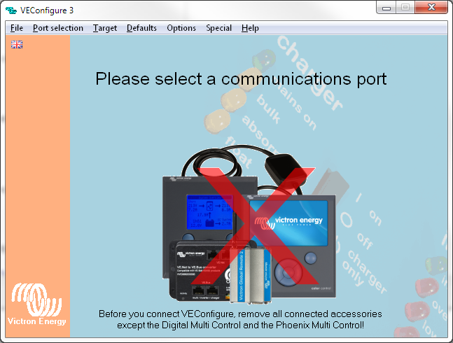
- When using firmware xxyy250 or higher on an inverter, the following message is displayed on the charger pane:
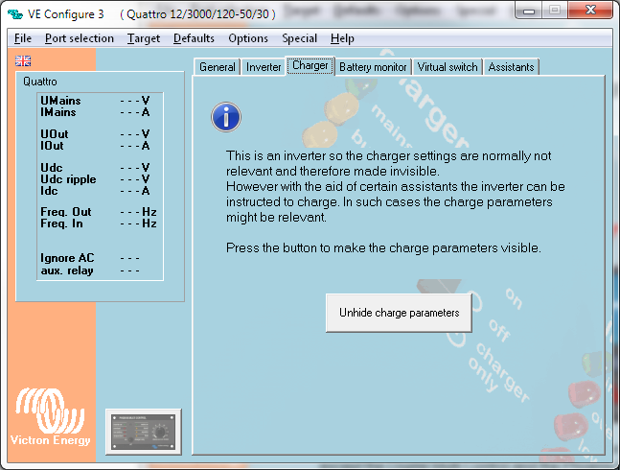

V9004164 – Released 31-7-2013

Changes for the user:
- Enable battery monitor checkbox added.
- Float voltage LiFePo4 batteries changed to 13.5V

V9004163 – Released 29-7-2013

Changes for the user:
- On some windows systems, VEConfig could not communicate with old VE9bit devices. This is rapaired.

V9004162 – Released 24-7-2013

Changes for the user:
- Bug removed. Some assistants (i.e. ‘Self-consumption Hub-2 v2’) were not saved to file correctly. The result was that they could not be read back.
A warning ‘This files does not contain assistants!’ was issued during read of the file.

V9004161 – Released 19-7-2013

Changes for the user:
- Pressing ‘cancel’ on an assistant will undo all the changes so-far. (Previous versions of VEConfig only stopped the assistant but kept the changes done before the cancel)
(Due to this new behavior one cannot start more than 1 assistant at a time anymore. So for each assistant one has to press ‘start assistant’)
- The displayed value of IMains has a token now. Negative IMains means energy flowing out of the Multi.
- Charge efficiency for the battery monitor setting added. (Available from firmware revision 205 and up)
- When VEConfig is started directly (i.e. not via VE.Bus Quick Configure or VE.Bus System Configurator) one can only connect to stand alone devices.
If a VE.Bus system is detected an error message will be displayed instructing you to use either VE.Bus Quick Configure or VE.Bus System Configurator to start VEConfig with.
This to prevent the common misconception that VEConfig communicates with the device to which the MK2 is connected. (This is not true, VEConfig used to connect to the Leader of phase L1, no matter where in the system the MK2 was connected.)
So, from now on to change settings in a VE.Bus system one has to start VE.Bus Quick Configure or VE.Bus System Configurator.

V9004160 – Released 13-6-2013

Changes for the user:
- Some small changes made for translation purposes.

V9004159 – Released 17-5-2013

Changes for the user:
- Some ‘textual’ changes made because of translation purposes.

Changes for future improvements
- Improvement for modifying settings in VEConfig by Assistants
(introduced in 157, but not used in any assistant yet)

V9004158 – Released 14-5-2013

Changes for the user:
- Bug removed: The Bus monitor displayed the output power (VA’s) of L2 and L3 ‘over’ the output power of L1.

V9004157 – Released 8-5-2013

Changes for the user:
- Assistant window:
  - can be resized
  - can contain links
  - is VEConfig color
- BusMonitor
  - is not ‘modal’ anymore. It can be left open while working with VEConfig.
  - contains VA’s for every phase
  - contains Ignore AC, Aux relay and SOC.
  - Frequency includes one extra digit.
- If fake with full options is cancelled the previous selection (12/24/48 Vdc & 120/230Vac) is restored.

Changes for future improvements
- Assistants can be made smaller
- Assistants can change settings in VEConfig. So if certain settings are required the assistant can perform this for the user.

V9004156 – Released 25-3-2013

Changes for the user:
- Bug removed. Previously saved assistant setups could not be loaded under all circumstances.
- Lithium Iron Phosphate battery default added.

V9004155 – Released 21-3-2013

Changes for the user:
- Option to specify a ‘private’ assistant directory where assistants for demo purposes or development can be placed. This way the user does not need to copy *.VAP files into the installation directory anymore.
- Updated the internal fake device so in demo mode the latest assistants can be used.

v9004154 – Released 11-1-2013
Release required due to an issue with updating assistants.

Changes for the user:
- negligible

v9004153 – Released 13-11-2012

Important notes:
- This version is distributed via the automatic update system.
(Versions prior to 9004152 require a complete re-install, this is automatically handled)

Changes for the user:
- Assistants are treated as settings as much as possible. So saving settings will also save assistant setup and loading settings will load the assistant setup.
Also programming and reading the assistants from the device is done with Send Settings and Get settings.
- Removed bugs:
  - Virtual panel did not function.
  - Loading saved assistants would set the assistant values to default.

v9004152 – Released 27-9-2012

Important notes:
- Systems using versions earlier than 9004152 will NOT receive updated assistants anymore!
- This version is not distributed via the automatic update system. To update, download the latest version via the VEConfigure 3 link on the website.

Changes for the user:
- When using multi firmware 19yy202/20xx202 or higher, the assistants will be read without the VE.Bus device being switched off. Also the speed of reading and writing of assistants is increased.
- Assistants can now also be used when a target is faked from file.
(The .VSC file format had to be changed for this purpose. Therefore VEConfigure versions before 9004152 cannot read .VSC files created by version 9004152 or later.
Version 9004152 is capable of reading files created with previous versions)
- Fixed bug in changing assistant values to default (via the right-click sub menu).
- The indication that ‘outdated’ assistants are used is now also updated after new assistants are downloaded and not only when the assistants are read from the target.
- During installation the VSC extension is ‘connected’ to VEConfigure 3: double clicking a .VSC file will automatically open VEConfigure 3 with that file.
- VEBus settings (parallel/3-phase etc.) are now available for use by the assistants.
This allows assistants to change their code automatically depending on whether they are programmed in a slave or a master.

v9004150 – Released 22-6-2012

Important notes:
- First released version of VEConfigure 3.
- Not distributed via the automatic update system. All customers that have VEConfigure2 installed will therefore not be automatically updated to VEConfigure3.

Changes for the user:
- Support for assistants has been added. Note that this needs a VE.Bus device with firmware xxxx200 or higher.
Note that VEConfigure 3 can still configure devices that have older firmware, in other words: everything that could be done with VEConfigure 2 can also be done with VEConfigure 3.
- VEConfigure 2 renamed to VEConfigure 3

