MPPT Control Firmware change log

How to update?
To be able to install the firmware, the MPPT Control has to be powered using below depicted battery cable. Use that cable to power the MPPT Control through its RJ-12 port. How to connect to the data port depends on the update method, see instructions below the pictures.
All MPPT Controls are supplied together with that battery cable, its inside the MPPT Control packaging. But, as most of today’s installations don’t require the cable to be installed it could be that you don’t have it available. Only MPPT Charge Controllers dating year 2015 or earlier did. Therefore, in case the cable is no longer available, contact your dealer to get a (free) spare – and note that he might need to get it from Victron Repairs, this might take some time in transportation.
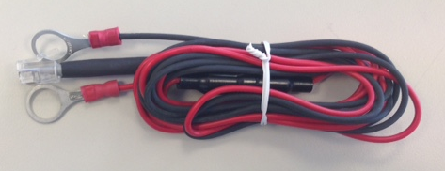

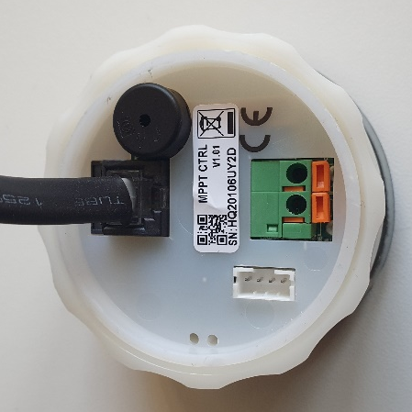

The firmware can be updated by either of the following methods:
- Using a VE.Direct to USB interface (part number ASS030530010) and VictronConnect v5.34 or newer. VictronConnect is available for download from our website:
https://www.victronenergy.com/panel-systems-remote-monitoring/victronconnect.
- By connecting the MPPT Control to a Venus device with internet connectivity using a VE.Direct cable (for example the one that is used to connect the MPPT Control to the MPPT) and then use the remote firmware update functionality of the VRM website: https://vrm.victronenergy.com

What version do I have?
To see what firmware version is installed on a MPPT Control, keep setup pressed for 2 seconds, then go to entry "20 SOFTWARE VERSION" using up and down, and press select.

Change log:
v1.03 – 27 September 2021
Changes:
- Solve MPPT Control getting stuck in "CONNECTING"
- Make the communication more robust
- Add support for new MPPTs
- Fix that when autolock is set to false, it would still lock 1 more time.
- Fix display of MPPT software version
v1.02 – 6 October 2020
Changes:
- Solve MPPT Control getting stuck in "FETCHING HISTORY"
- Make the communication more robust
Together with firmware v1.02 for the MPPT Control, also firmware updates for the MPPT Solar Chargers were released: v1.53 for the MPPTs without VE.Can comms port, and v3.02 for the MPPTs with VE.Can comms port. These also fix issues leading to “FETCHING HISTORY”.

To eliminate any chances of the MPPT Control getting stuck on the “FETCHING HISTORY” message, make sure to update both the MPPT Solar Charger as well as the MPPT Control. And in case the MPPT Control Battery Cable is not available, we advise to try and first update the MPPT Solar Charger only; it might solve the issue.

Firmware v3.02 for the MPPTs with VE.Can solves a problem where the MPPT Control would not update the 30 day history and the history would always show the data from when the MPPT Control was first connected to the MPPT.

v1.01 – 13 December 2018
Changes:
- Allow editing of load switch high/low, but is now possible when the load output is set to USER1 or USER2.
- Variable amount of decimals, depending on the value, when showing "TOTAL TIELD"
- Show "YIELD TODAY" in 0.01kWh steps
- Support new MPPTs and newer firmware version
- Add equalization voltage setting "24 EQUALIZATION VOLTAGE"
- Add manual equalization start/stop under setting "25 EQUALIZE"
- Remove load output status for units with virtual load output, as the virtual load output cannot be used together with the MPPT control.
- Fix 30 day history for MPPTs that stay on at night (all new MPPTs)
- Show the correct fixed battery type text
- Show the correct saving result
- Make sure the sign position is empty when not negative
- Make the communication more robust
v1.00 - 2 July 2015
Changes:
- Initial version

