LiFePO4 24V series compatibility with the Lynx Ion BMS

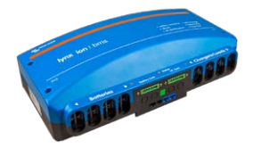

The Lynx Ion BMS replaces the older Lynx Ion + Shunt 350A and 600A models. This document explains the details about battery compatibility and required firmware updates.
Lynx Ion BMS compatible batteries:
Lithium HE series:
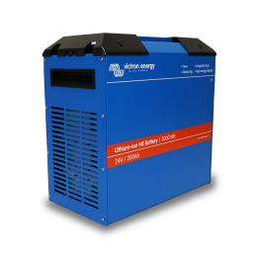
BAT524110300 - Lithium HE battery 24V/100Ah 2,5kWh
BAT524120300 - Lithium HE battery 24V/200Ah 5kWh
All produced Lithium HE series batteries are compatible.
LiFePO4 24V series:
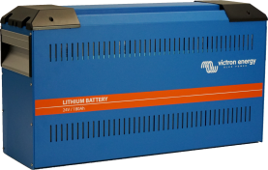
BAT524181200 - LiFePO4 battery 24V/180Ah 4,75 kWh
BAT524101200 - LiFePO4 battery 24V/100Ah 2,6 kWh

A new firmware version has been made available for the LiFePO4 24V series, to make it compatible with the new Lynx Ion BMS. This document explains the details and how to update.

Chapter 1: LiFePO4 24V series compatibility details
Not all sold and shipped units can be updated. Use the serial number to determine compatibility:
- HQ1641xxxxx and newer: compatible straight out of the box.
- HQ1515 up to and including HQ1640xxxxx require a firmware update. See below for instructions.
- HQ1514xxxxx: some can be updated, others cannot be updated. See Appendix A.
- HQ1513 and before: not compatible, and can also not be updated to become compatible with this new BMS. Background: there is a hardware change halfway during the HQ1514 batch, which is required for the battery to be compatible with the Lynx Ion BMS.
Note that, upon connection, the Lynx Ion BMS makes a change in the battery software settings. This change renders the connected batteries incompatible with the "Lynx Ion 350" and "Lynx Ion plus Shunt 350/600".
Update the battery again with the "MG USB-CAN Transceiver" to restore operation with the "Lynx Ion 350" and "Lynx Ion plus Shunt 350/600".

Chapter 2: Firmware updating instructions
To update the LiFePO4 24V batteries, it is required to first send the serial number of the battery to the contact person below. Then you will receive a unique ID for each battery that is required for the update.
Required hardware is the “MG USB CAN Interface”. The normal Victron CANUSB cannot be used. The required PC software is only supported by Windows 7 or 10 operating systems.

For support when updating the firmware, contact Victron at level3support@victronenergy.com.

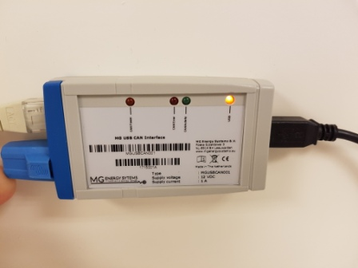

Appendix A – HQ1514 serial numbers that cannot be made compatible
Below list of HQ1514 serial numbers cannot be updated to the required firmware version for the Lynx Ion BMS.
All HQ1514 batteries with a serial numbers not on below list can be updated to make them compatible with the Lynx Ion BMS. See Chapter 2 for instructions.
HQ1514EY8VD | HQ15148CKL1
HQ1514ZRYSK | HQ151423N47
HQ1514YLYWX | HQ1514JVHPL
HQ1514IEFP7 | HQ1514FQA2F
HQ1514AX2X9 | HQ15141MI9J
HQ1514CRV9A | HQ15141FSVG
HQ15149SL6Q | HQ1514MXECI
HQ1514M7JU8 | HQ15147UJ4E
HQ1514VG872 | HQ1514AET5L
HQ15147JEFB | HQ1514EBAN6
HQ1514S8EU7 | HQ1514MBGS4
HQ1514YZW6H | HQ15143REFG
HQ1514E1VML
HQ1514MTT7U
HQ1514YFB25
HQ151457Q75
HQ1514RG918
HQ1514QJIAN
HQ1514EPGLW
HQ1514F2TEY
HQ1514K82A4
HQ15149AD37
HQ15141EZZM
HQ1514GR61Z
HQ1514WJ9KY
HQ1514AYZZN
HQ1514RYKBW
HQ1514ATSPR
HQ15144RGXK
HQ1514LZL49
HQ1514VD1JE
HQ1514DXSCS
HQ1514W24VS
HQ1514Y6HIQ

