Lynx Ion – how to upload new firmware
Note that updating only works on Windows. From both Linux and Apple users we have reports that it didn’t work, and that they only managed to make it work on a Windows machine.
Determine hardware version
The necessary procedure depends on the hardware version you have. Products without any revision (REV) related markings are REV1.
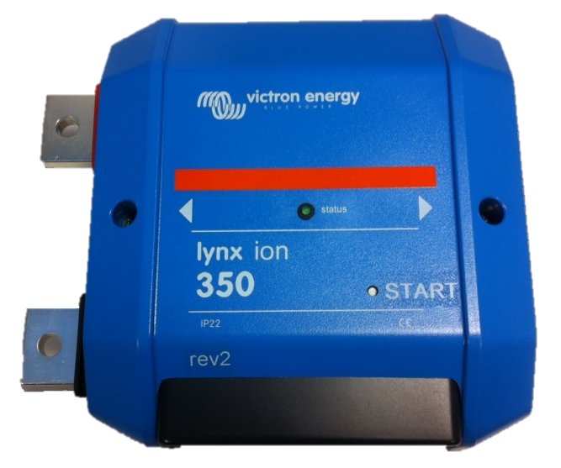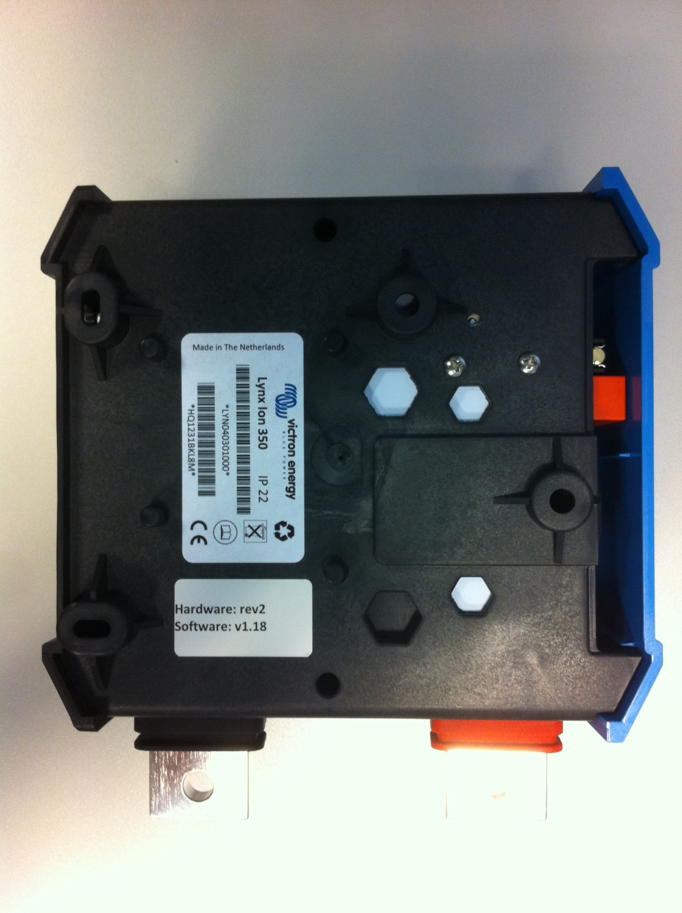
Revision

Uploading new firmware to the Lynx Ion first hardware version
- Connect the USB cable to the Lynx Ion as below.
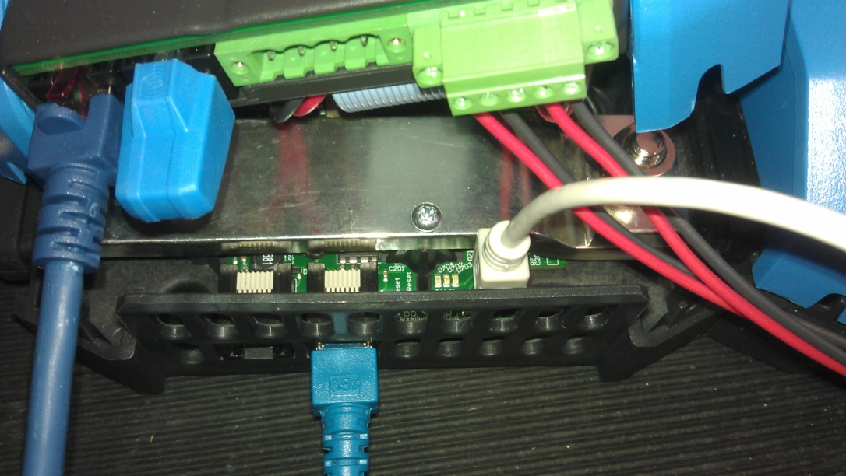
Micro USB
- Connect the other side to a windows PC.
- Now press the right button on the front. Keep it pressed while pressing and then releasing the left button. The device now resets and starts up into bootloader mode.

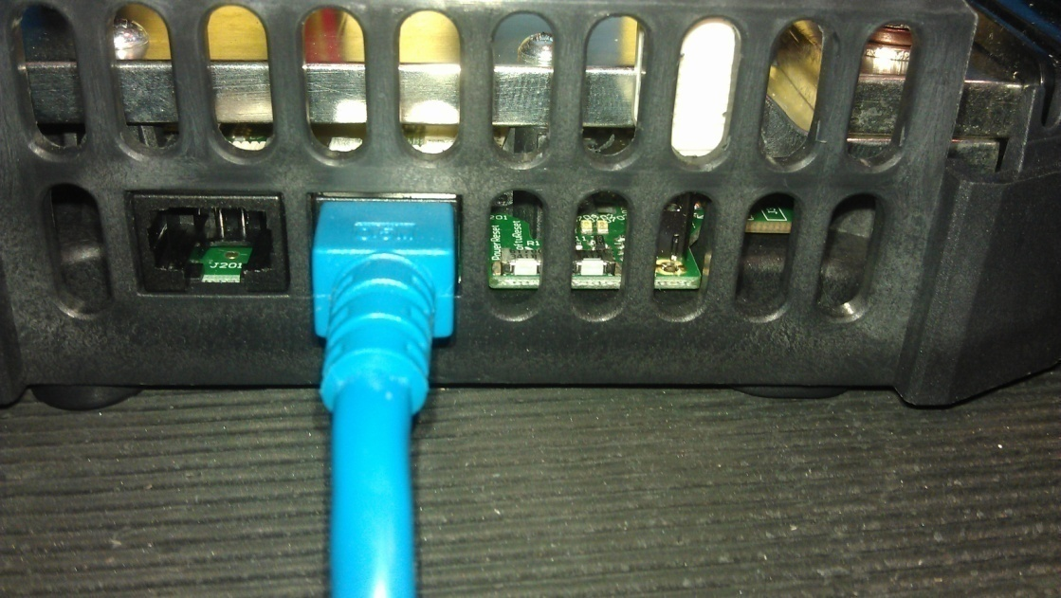
Right Button (Bootloader)
Left Button (Reset)

- On the PC a mass storage device will be added with the name “Lynx_Ion”.
- Delete the “firmware.bin” file from the disk.
- Now drag the new firmware file (*.bin) to the disk.
- If it is done copying press the left button to reset the device.
- Now the firmware update is complete.
- Restart the system with the START key.

Updating new firmware to the Lynx Ion for “rev2” or higher Lynx Ions
- Connect the USB cable to the Lynx Ion as below.
Micro USB
- Now hold the START key pressed until the system starts-up (status LED is blinking fast) and the status LED is continuously on.
- Now release the START key.
- The status LED is blinking slow and on the PC a mass storage device will be added with the name “Lynx-Ion1.1”.
- Delete the “firmware.bin” file from the disk.
- Now drag the new firmware file (*.bin) to the disk.
- If it is done copying, remove the USB cable from the Lynx Ion.
- Wait until the status LED goes off.
- Now the firmware update is complete.
- Restart the system with the START key.

