SmartLithium changelog

How to update?
Update using VictronConnect. This program is available for download on https://www.victronenergy.com/software/.

What version do I have?
Firmware version is visible in VictronConnect.

Change log:

v1.28 – 20 July 2022
- Removed Stored Trends. This feature was introduced in version v1.27 but it causes problems with some batteries. These batteries were no longer shown in VictronConnect and stopped both charging and discharging. The batteries will come out of this situation by itself, but that can take up to two days. Stored Trends are planned to be re-added later in 2023.

v1.27 – 17 May 2022
- Support for Runtime Data Advertisement
- Adds Stored Trends
Known issue: due to a bug in the firmware, some batteries render themselves unusable. This happens
approximately 50 days after installing and when rebooting. To minimize the risk:
  - asap update to v1.28. Next week (week of July 26th) we will release a new VictronConnect version that will take care of that automatically upon connection to the battery.
  - do not use the “Restart controller” feature in the menu.
  - do not reinstall v1.27 once already installed.

v1.26 – 20 October 2021
- Fix production issue.

v1.25 – 19 July 2021
- Fix issue where Bluetooth continues to advertise when Bluetooth is disabled.

v1.24 – 08 June 2021
- Balancing state timeout extended from 14 to 35 days. The instruction to customers is to charge at least once a month to keep the batteries balanced. A charge interval of 30 days should not lead to an unknown balancing state.

v1.23 – 01 June 2021
- Time since last full balancing indicator. This indicates the time since the battery was fully charged and balanced. It is recommended to fully charge the battery at least once a month.
- Extension of charger disconnect depending on peak cell voltage. This to give the balancer more time to balance the high cell before charging is turned on again. In some systems, there is a delay between the charger disconnect signal and the actual stopping of the charger. This may cause higher cell voltages and can get worse when the charger is turned back on too soon, resulting in a new overvoltage alarm. Therefore a delay of 1-20 minutes is added depending on the peak cell voltage. During this delay, the balancing process continues. This reduces the number of overvoltage alarms and protects the cells against excessive high voltages.

v1.22 – 23 April 2021
- Balancer status indicator showing the state of imbalance between the cells in VictronConnect. It shows the current balancer status and indicates whether it is necessary to rebalance the cells.
- Support for reset command so a user can manually reset the controller in case of issues as it is not possible for a user to power cycle the battery.
- Fix a rare issue with Bluetooth, where the BLE connection does not return properly from a connected state making it impossible for the user to reconnect to the device again.

v1.21 – 01 December 2020
- Balancer firmware update that fixes tester/production issues of v1.20. Serial number is now readable using the HEX protocol and balancers no longer fall asleep in tester mode.

v1.20 – 06 November 2020

- Added ability to re-enable BLE again after it was disabled by the user. To re-enable BLE, a specific pin of the BLE module has to be connected to the module shield for 5 seconds. Note that the cover of the battery has to be opened to re-enable BLE. This can damage the battery housing. See the manual for more detailed information.
- Improved recovery mechanism to prevent balancer hangup when an internal error occurs

v1.19 – 24 June 2020

https://www.victronenergy.com/blog/2020/07/06/victronconnect-v5-27-lithium-smart-v1-19/

- Fix issue with 12V batteries where cell 2 and cell 3 had a lower voltage when the battery was not charged for some time. (12V batteries only)
- Fine-tuned balancer behavior; including much better “self-restoration” of imbalanced batteries when applying normal charge. In such imbalance situation, the charger will still be enabled / and disabled continuously through the BMS since that’s how the mechanism works and this has not been changed compared to the previous version; but in this new version, the balancing will continue much better throughout this enabling/disabling process. Note that, when/once the cells are balanced, the allow-to-charge signal will no longer be disabled; even when the battery is fully charged and the charger is in Absorption. All cells will then be at 3.55 Volt = 14.2 Volt = the recommended absorption voltage.

v1.18 – 14 May 2020
- Adds 12V/50Ah model. Released only for that model & no feature changes compared to v1.17

v1.17 – 27 May 2019

- Support BMS Pre-Alarm signal and under-voltage warning in VictronConnect.
Note: this is for models that support the BMS Pre-Alarm signal only.
- Support turning off Bluetooth interface from within VictronConnect.
- Support last settings modification date (*).
- Support indication of default Bluetooth PIN (*).
- Support advertising connection state while being connected to VictronConnect (*).
- Improved reliability of Bluetooth connection during firmware updates.
Note: after updating, one needs to drop the existing bond information and pair again to reconnect.
- When changing the PIN, drop the existing bond information, such that user needs to pair again when reconnecting.
- Fix issue with custom device name and Bluetooth advertisement.
- Fix issue with VE.Smart networking, where communication could come to a halt.
- Fix issue where cell 8 voltage was not properly monitored (24V batteries only).
- Fix issue where BMS outputs may toggle after a firmware update.
- Several internal improvements.
- Ships bootloader v1.06

(** continues on the next page**)

v1.16 – 13 February 2019

Fix temperature inaccuracies. The accuracy of the battery temperature measurement varied too much. In this update; three changes have been made that together fix that:

- The battery will, only once, automatically calibrate the temperature measurement when no balancing have been active for four hours.
- Added “Battery temperature offset” user setting, range -10°C to +10°C. This can be configured through VictronConnect. Most batteries will be accurate enough once automatically calibrated. This setting has been made available for those that still need further (manual) calibration.
- Stabilized battery temperature indication by filtering it over time.

So, after updating to this version, the user can do one of two things: wait for the automatic calibration to take place. Or go in and set the Temperature offset immediately. When doing so; the automatic calibration will not take place anymore; ie. there is no need to worry about the self-made calibration to be overwritten.

Note that a new firmware version of VictronConnect is required to change the Battery temperature offset setting. Which is planned for official release by end of February 2019. The easiest process is to wait until then; it will automatically install the update. For systems that need this update sooner; use the manual firmware update procedure in VictronConnect.

Lastly, this firmware update adds the possibility to change the name under which a battery appears in the VictronConnect list of devices.

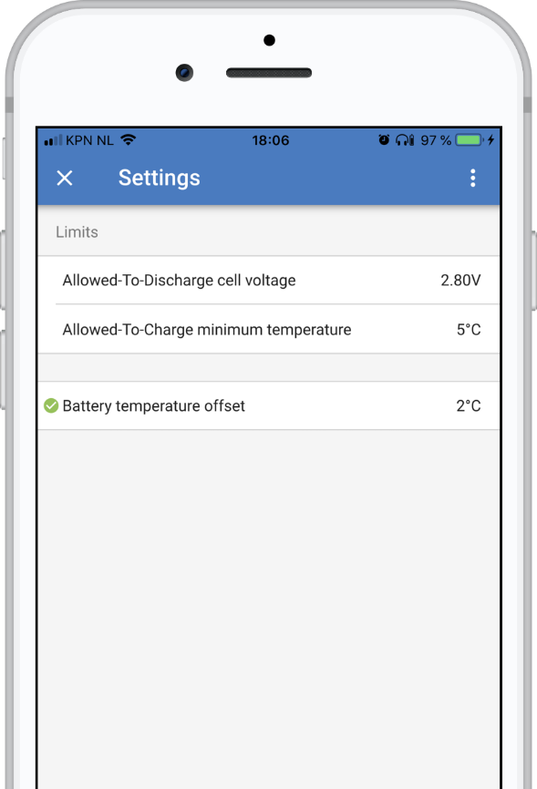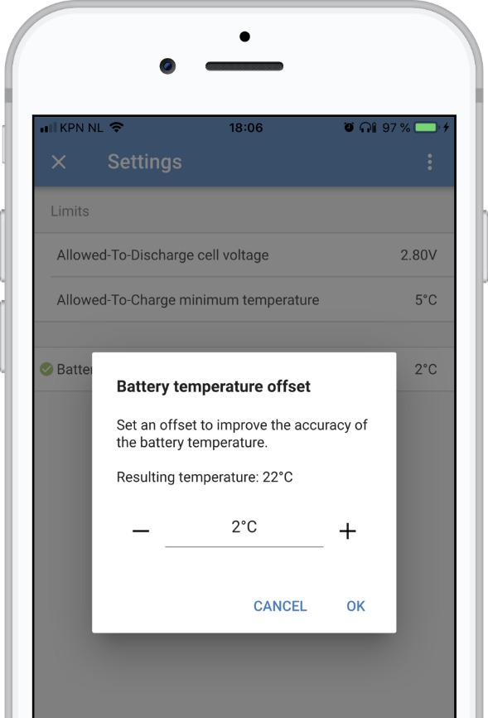

v1.15 – 23 November 2018
- Improved Bluetooth connection.
- Ships bootloader v1.05

v1.14 – 29 October 2018
- Added under temperature alarm: the battery signals for the charging to be disabled when the temperature drops below 5°C. The under temperature threshold is 5°C by default, and is configurable in VictronConnect (range -20°C to +20°C).
- Ships bootloader v1.04.

Prior releases are not documented here.

