Carlo Gavazzi EM24 firmware

How to update?

First install the UCS-7 tool provided in the same location as this document, normally on https://professional.victronenergy.com/, on your computer.

The reason to use that version of UCS rather than the one available for download at the Carlo Gavazzi website, is that per mid 2022, the newer versions require an authorisation code before accepting to install a new firmware in this meter.

Next, follow the instructions below, chapter “Update process”.

How to see which firmware version is installed?

Using the GX Touch or login to Remote Console, navigate to the Device list, then to Grid and then to the Device submenu. Below screenshot shows version v1.3.30
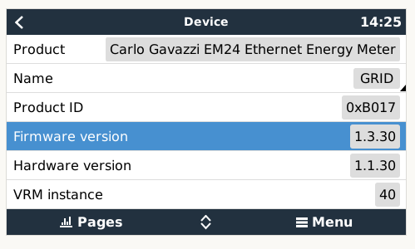

Document Changelog:

April 2023 – firmware v1.8.x
Changes:
- Fix meter getting stuck: add a timeout on socket_recv function in order to prevent it from getting stuck in case of false event of received packet.
- Other improvements

August 2022
Changes:
- A copy of UCS7 that is known to work properly is now provided for download on professional.

June 2022 – firmware v1.7.x
Changes:
- Better handling for multiple TCP/IP connections. Maximum 5 concurrent connections are allowed. In previous versions, more concurrent connections could cause random errors including lockup requiring a power cycle or reconfig.

January 2021 - firmware v1.6.x
Changes:
- Fix (rare) instability issues leading to the meter locking up, and requiring a power cycle to resume operation.
- Fix (rare) instability issues leading to the meter restarting, and thus loosing connection and then reconnecting, every couple of minutes in some systems (seen on just one system). A continuous restarting meter can cause various issues, it will affect ESS operation stability, and it can also cause the kWh data on VRM to be below actuals.

Rest of changelog is unknown at the moment. Until early 2022, most Carlo Gavazzi EM24 ethernet meters as supplied by Victron are shipped using v1.3.30.

Update process

First obtain the IP address of your meter. This can be found on the LCD of the EM24 meter (by pushing the toggle-lever to the right), or on the GX device by navigating to the meter, and then to Device, and looking for the Connection value.
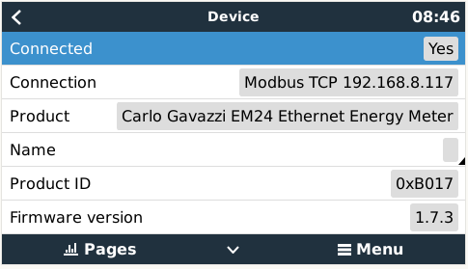

Now start UCS7. Then select Manual Connection.

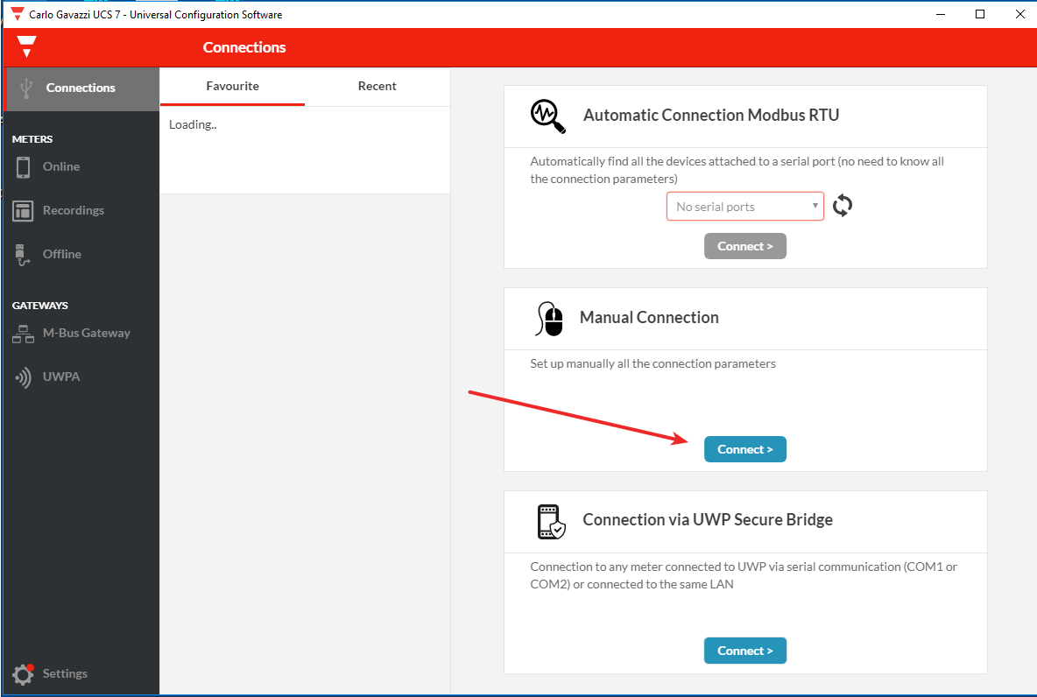

Then select Modbus-TCP and enter the IP address of the meter as recorded earlier. Click Connect.

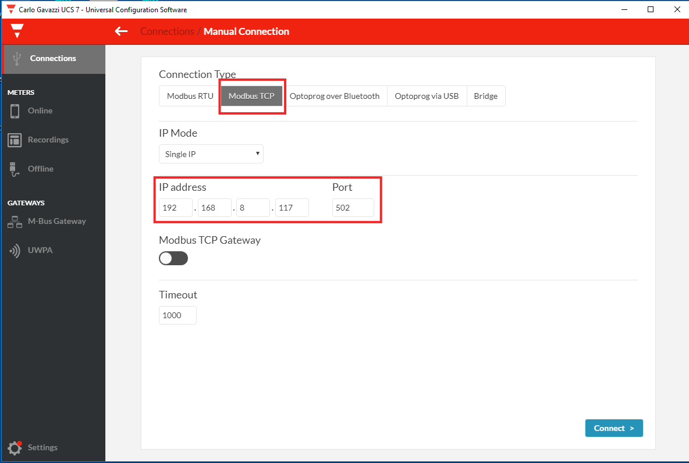

Click on “Online” to see the detected meters. Then select the (only) meter.

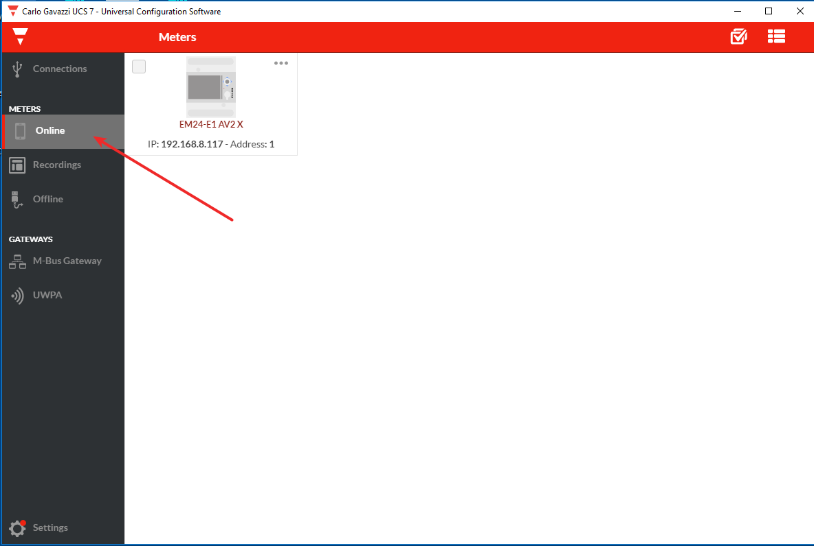

Click the Settings icon

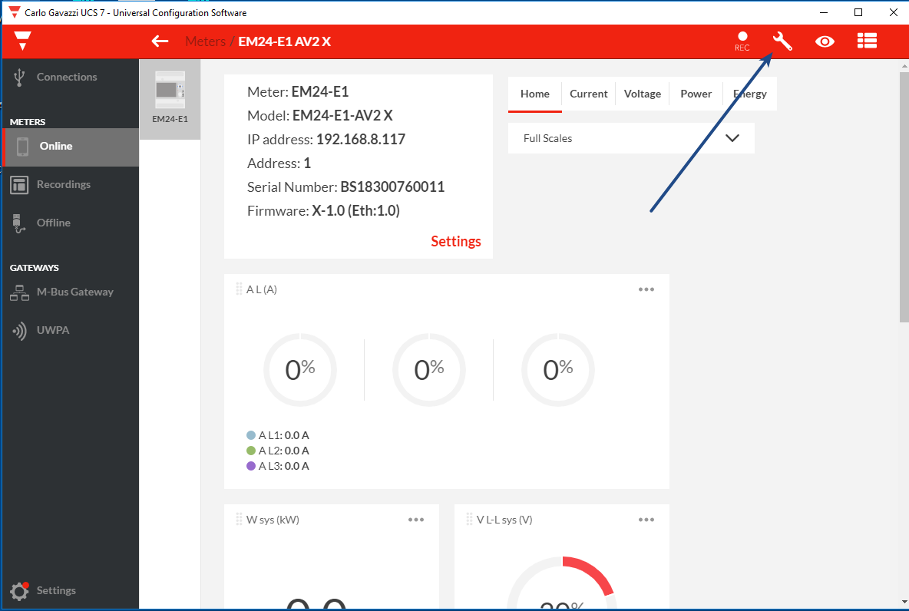

Then click “Firmware Update”

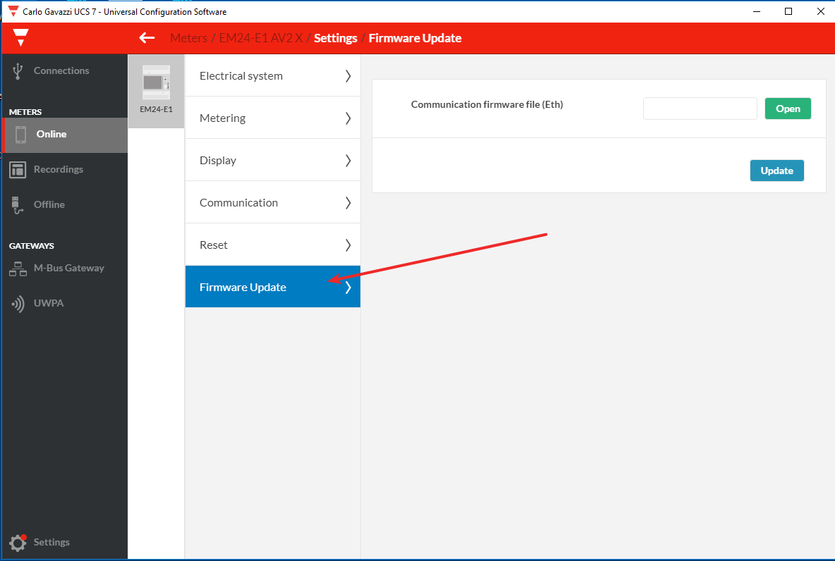

Select the firmware file you downloaded from https://professional.victronenergy.com/ and continue. The firmware update will take about a minute, and this screen will show:

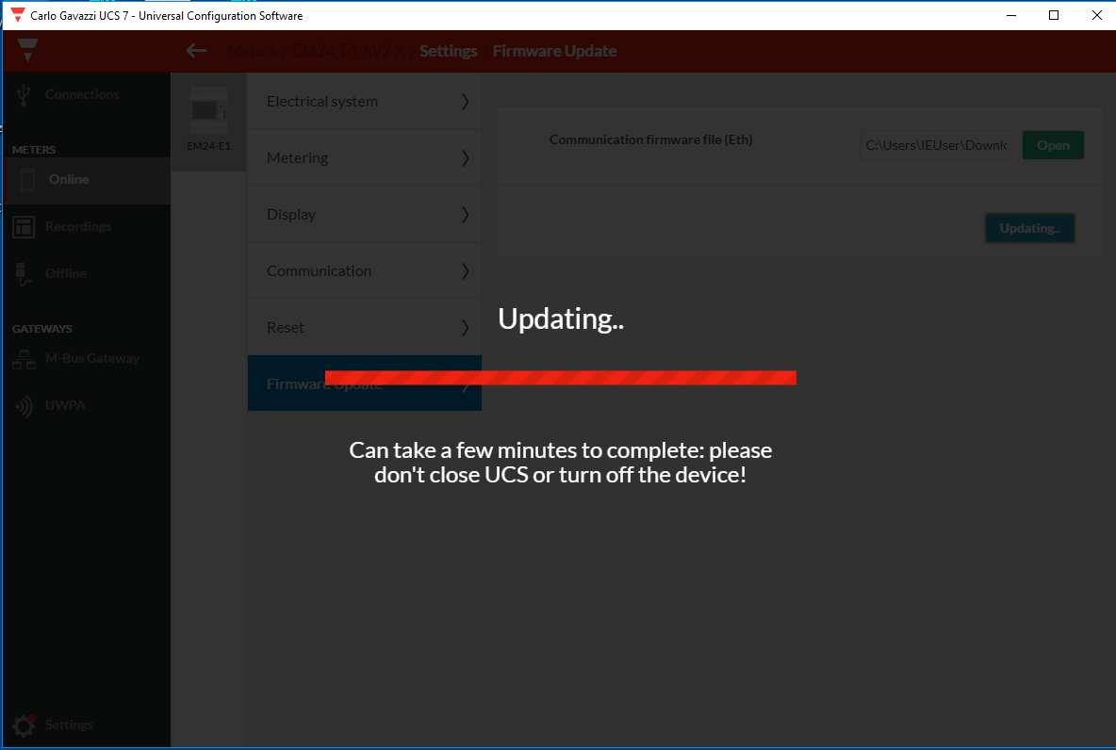

That concludes the firmware update process.

