BMV-700 series changelog

How to update?
Update using VictronConnect. This program is available for download on https://www.victronenergy.com/software/. Special hardware is required. Use either the VE.Direct to USB interface (part number ASS030530000), or the VE.Direct Bluetooth Smart dongle (ASS030536010) is required.

What version do I have?
Firmware version is visible in the setup menu, item 61. And also visible in VictronConnect.

Changelog:
V3.11 – 2 February 2021
- Fixed wrong relay activation due to using uninitialised voltage measurement at startup.
- Fixed returning wrong invalid value for VE_REG_DC_CHANNEL2_VOLTAGE when auxiliary input is not set to starter/aux (will return 0x7FFF now instead of 0xFFFF).
- Changed minimum accepted temperature for alarm/relay to -40 Celcius (was -99 Celcius).
- Added "None" option to auxiliary input configuration. The "None" option is the default configuration. Settings 22-31, 39-48, 58-60, 67-68 are disabled in the settings menu (display) when the aux input is configured to "None".

v3.10 – 23 November 2018
- Fixed the problem that was introduced in the v3.09 release, where the settings were reset to their defaults upon an update from v3.08 (or earlier) to v3.09.

Important: when updating from v3.09 to v3.10, the settings will be reset to their defaults once
more, due to the bug introduced by the v3.09 firmware.

v3.09 – 31 October 2018 – cancelled due to bug!
- Added option for powering up in an unsynchronized state through setting #70 START SYNCHRONIZED (ON/OFF), ON by default. When set to OFF, the state-of-charge, time-to-go, and consumed energy are unknown until the first actual synchronization. Relay and alarm conditions based on these unknown parameters are disabled. The display’s CHARGE and (empty) battery indicator segments will blink.
- Battery indicator now scales between the configured discharge floor and 100% state-of-charge, instead of the full state-of-charge range (0% - 100%). Note that the State of Charge itself still scales between 0% and 100%; nothing has changed there.
- Fixed an issue related to changing the backlight intensity while connected to VictronConnect.
- Internal changes that do not change the functional behavior

This picture shows the ‘Battery Indicator’:
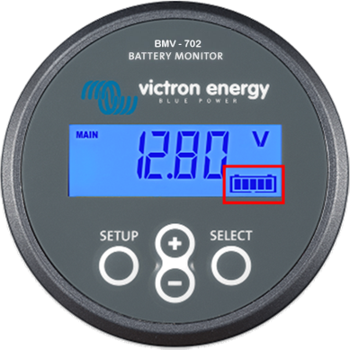

Known issues:
- When updating from v3.08 to v3.09, all settings will be reset to default. This issue was fixed in v3.10.

v3.08 – 13 July 2016
- Fixed some VictronConnect related issues: the mid-point voltage related alarms and relay settings were not shown due to incorrect format
- Fixed issue with Charged/Discharged Energy & Cumulative Ah (aka Total Ah Drawn) counters: the counters could get stuck at a certain value and become 'insensitive' for (small) changes
- More internal changes

v3.07 – 7 November 2014
- Alarm/relay: added 5 minute delay to mid-point voltage deviation condition to prevent alarms due to short term deviations

v3.06 – 28 October 2014
- Removed the un-synchronized state, so at power-up the SoC is 100%
- Shunt voltage setting max value changed from 100mV to 75mv, due to restrictions of the current ADC configuration

v3.05 – 3-march-2014
Changes for automated production testing.

v3.04 – 7-jan-2014
First approved version for mass production.

